Bahria University,

Karachi Campus

LAB EXPERIMENT NO.

**11**

LIST OF TASKS

|  |  |
| --- | --- |
| TASK NO. | OBJECTIVE |
| **1** | **Train a Decision Tree to predict whether or not a person earns more than 50k per year.** |
| 2 | Read classification data set and apply decision tree learner on it.  Show histogram and scatter plot of dataset |

Submitted On:

**Task 1:** Train a Decision Tree to predict whether or not a person earns more than 50k per year.

* Partition the dataset into a training set (75%) and a test set (25%) using the Partitioning
* Node with the stratified sampling option on the column “Income”.
* Use the Decision Tree Learner Node to train the model on the training set and
* The Decision Tree Predictor Node to apply the model to the test set.
* Use the Scorer node to evaluate the accuracy of the model.

**SOLUTION:**

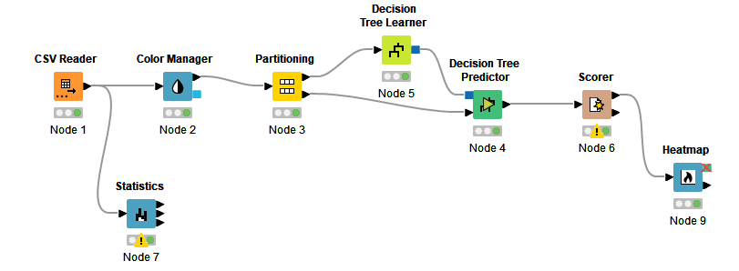

**DATASET (CHURN MODELING)**

**Csv reader:**

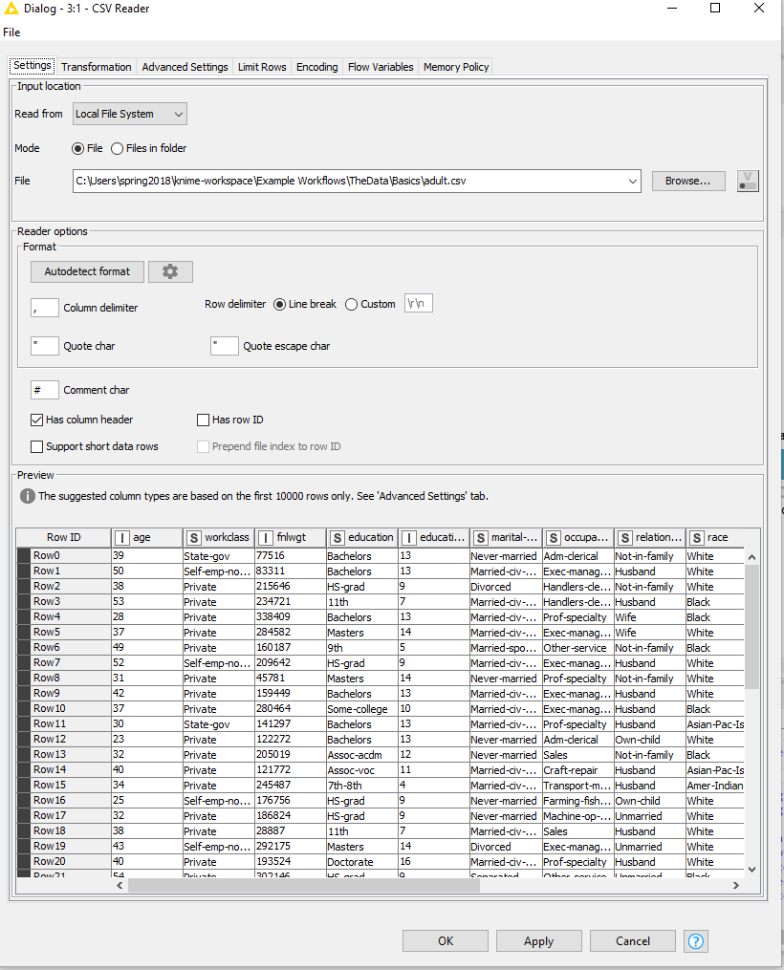

**Color manager:**

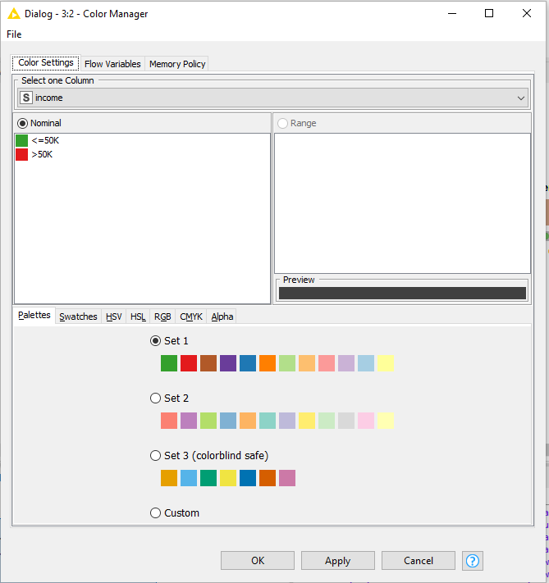

**Partitioning:**

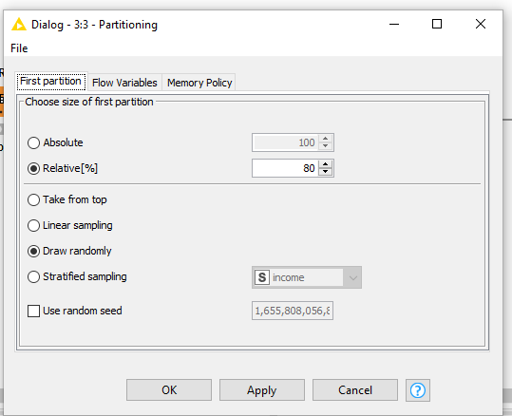

**Decision tree learner:**

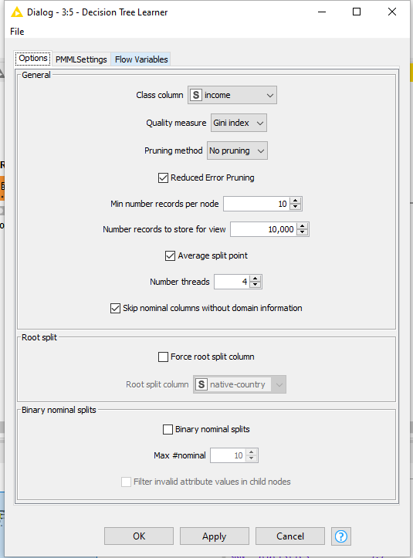

**Decision tree predictor:**

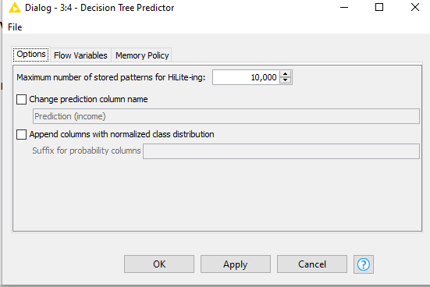

**Scorer:**

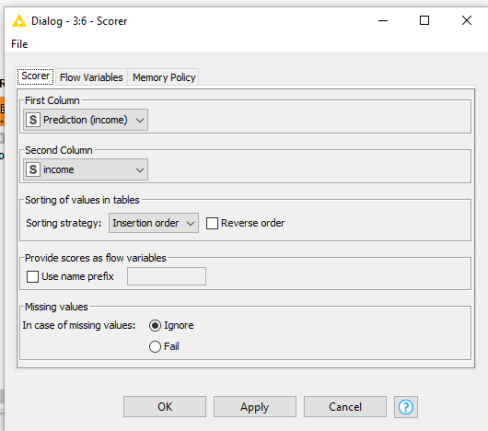

**Heatmap:**

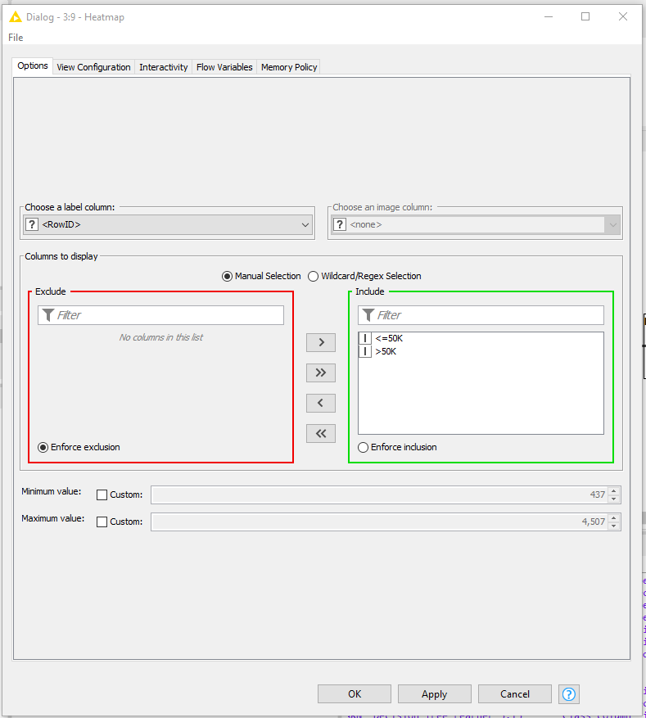

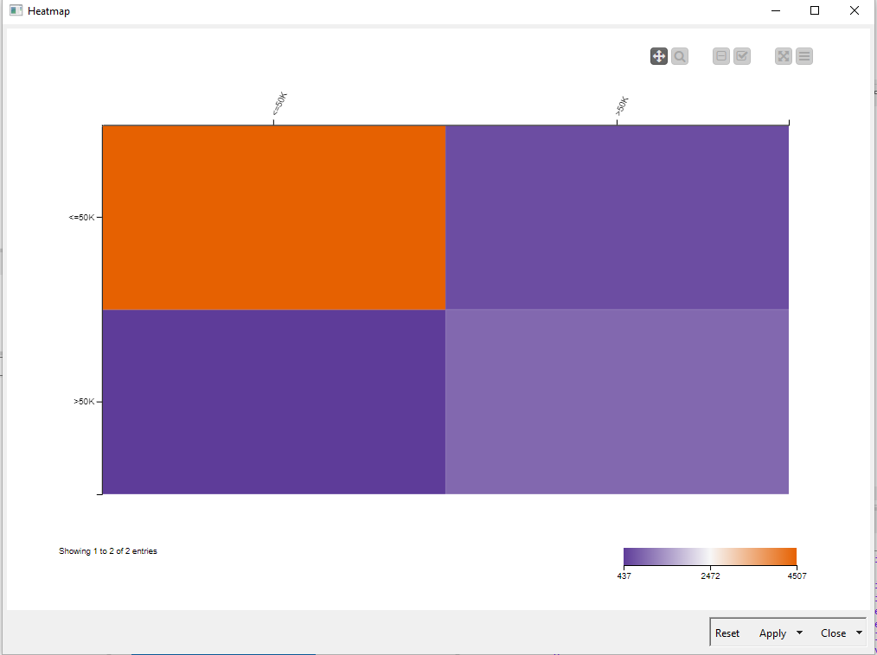

**Task 2: Read classification data set and apply decision tree learner on it.**

**Show histogram and scatter plot of dataset**

**SOLUTION:**

**Csv Reader:**

**DATASET (CHURN MODELING)**

**Category to Number**

**Color Manager:**

**Partitioning**:

**Decision tree learner**:

**Decision tree predictor**

**Scorer**

**Confusion Matrix**

**HeatMap**

**Statistics**

**Bar Chart**

